**29-11-2023 wednesday**

**EDGEX**

Devices&things <- Edgex platform -> cloud & enterprise applications

EdgeX Foundry is a vendor-neutral open-source platform hosted by the Linux Foundation.

providing a common framework for industrial IoT edge computing.

Edgex is comprised of many microservices and libraries.

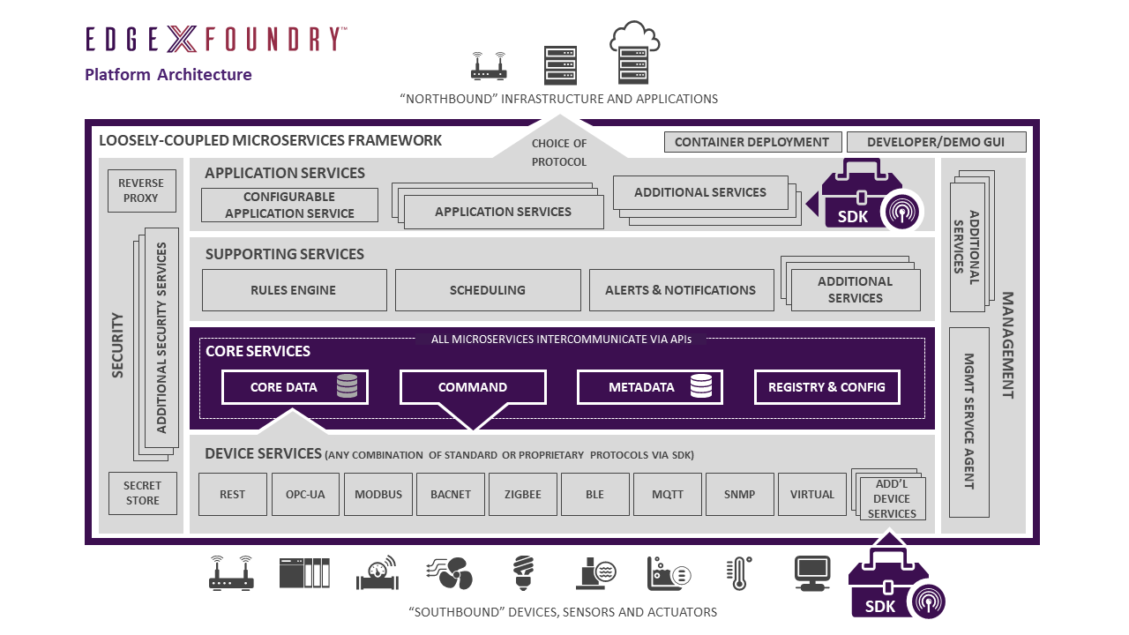

Platform agnostic

Extremely flexible

Store and forward

Secure and easily managed

**Edgex dataflow:**

Sensor data is collected by a device service from thing.

Data is passed to the core data for local persistence.

Data is passed to Application services for transformation, formatting, filtering and be sent to enterprise system.

Edge analytics trigger device automation through core command service.

Each service has a Rest Api to perform service operation .

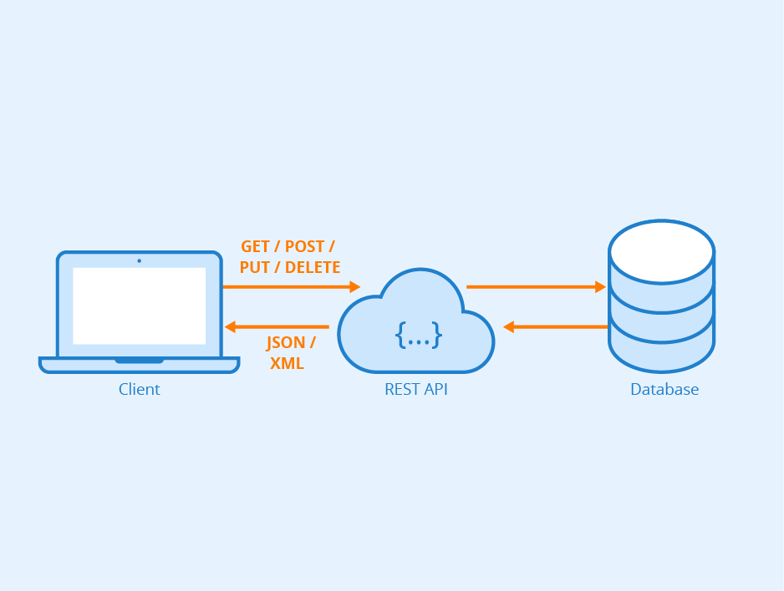

REST API is Representational State Transfer Application Programming Interface more commonly known as REST API web service.

It means when a RESTful API is called, the server will transfer a representation of the requested resource's state to the client system.

**Device services:**

Talk directly to the things-sensors or devices. -via protocol

Sdk provided to create your own.

**Application services:**

Get data to your enterprise applications,data lakes,cloud system.

transformation, formatting, filtering ,compressing data and then send to your Rest endpoint.

**Core Metadata:**

Knows about what devices/sensors are connected, what device service manages them, how to communicate with them.

**Core Data:**

Persist sensor data at the edge when desired.

**Core command:**

Proxy service when you want to send an actuation request to a device/device service.